## 

**Abbottabad University of Science & Technology**

# Department of Computer Science



**SOFTWARE DESIGN**

**DESCRIPTION**

**(SDD DOCUMENT)**

**Smart Donation**

Version 1.0

## *By*

**Hasnat Zeb** **(5487)**

**Ehsan Ullah (6325)**

## *Supervisor*

**Ms. Mehwish Sabir**

***Bachelor of Science in Computer Science (2018-2022)***

# Table of Contents

**Revision History ...........................................................................................................................**

**1. Introduction ............................................................................................................................**

**2. Design Methodology and software process model ..............................................................**

1. **System Overview ....................................................................................................................**  3.1 Architectural Design ..................................................................................................................

3.2 Process Flow/Representation .....................................................................................................

1. **Design Models [along with descriptions] .............................................................................**
2. **Data Design .............................................................................................................................**  5.1 Data Dictionary .........................................................................................................................
3. **Algorithm & Implementation ...............................................................................................**
4. **Software Requirements Traceability Matrix ......................................................................**

**8. Human Interface Design........................................................................................................**  . 8.1 Screen Images ............................................................................................................................

8.2 Screen Objects and Actions ............................................................................................................. **9. Appendix I ..............................................................................................................................**

# Revision History

|  |  |  |  |
| --- | --- | --- | --- |
| **Name** | **Date** | **Reason for changes** | **Version** |
|  |  |  |  |
|  |  |  |  |

**Application Evaluation History**

|  |  |
| --- | --- |
| **Comments (by committee)**  **\*include the ones given at scope time both in doc and**  **presentation** | **Action Taken** |
|  |  |
|  |  |

**Supervised by**

**Ms. Mehwish Sabir**

Signature______________

**Introduction**

This system is a web application that will be available to its users on any platform. The current system will provide the facility of Zakat Collection and Donation and managing both these. The donor will provide area information to the system and the nearby Deserving people will appear to whom the donor can directly visit and donate or donate indirectly by sending donations to the system and the system will give it to the deserving with generated receipts given back to the donor as proof of their complete donations. information providers will give info of the deserving (only if their monthly income is less than 17400 per month) that will include B-form, id card, signature and stamp of doctor & hospital (if patient) or signature and stamp of principal (if student) and signature and stamp of Mufti sahib (if Deserving family). The Admin and system will verify and prioritize the deserving accordingly and only the verified cases will be shown to the Donor when he searches the deserving in his area.

# Design methodology and software process model

Explain and justify the choice of design methodology being followed. (OOP or procedural).

**Incremental Model:**

For the project development I chose incremental model. In this model no need for good skills and well trained developers. Requirements are broken down into a small module. Incremental development is done in steps from analysis design, implementation, testing/verification, maintenance. Each iteration passes through the requirements, design, coding, and testing phases. And each subsequent release of the system adds function to the previous release until all design functionality has been implemented.

# System overview

Smart Donation is a platform that has multiple ways of donating to the poor community i.e. Zakat collection and donation. To commence with, people can donate zakat to a deserving family, a deserving patient, or a deserving student through this platform. Furthermore, the system will also have an account for people donating to the system especially from outside the country. Information providers will give information about deserving people (those who have monthly income of less than 17400 rupees) in their circle. The Admin and system will prioritize and verify the deserving people accordingly, then verified people will be shown to the donor when he searches in his area.

## Architectural design

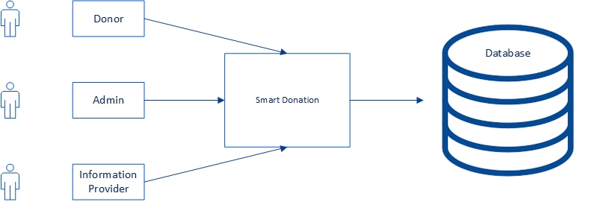

## Process flow/Representation

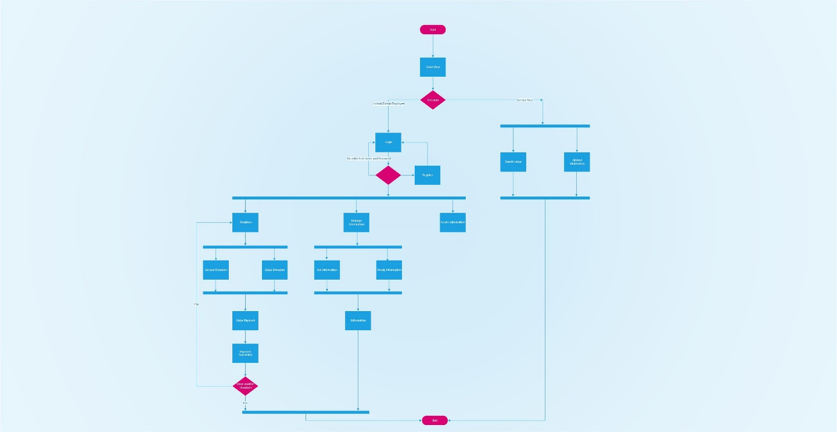

# Design models [along with descriptions]

**The applicable models may include:**

* Class Diagram

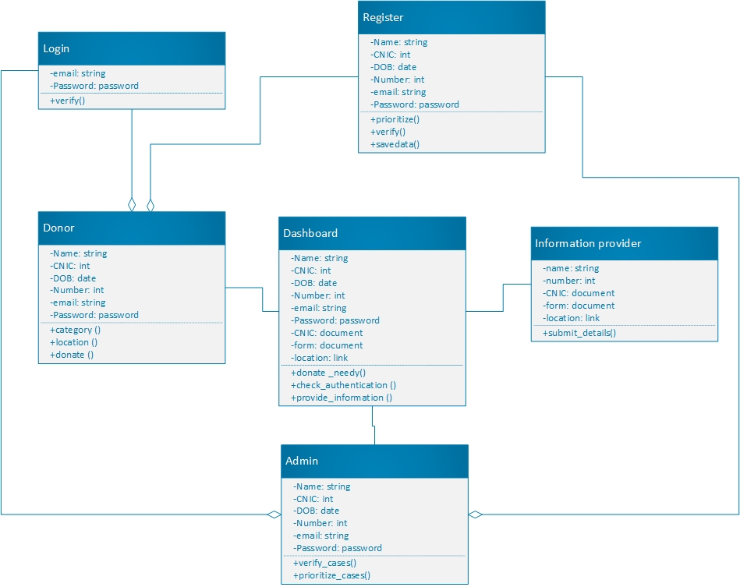

* Sequence Diagram

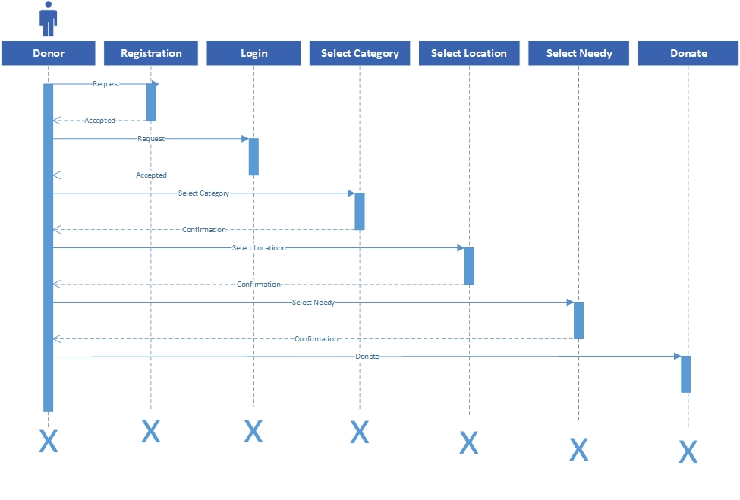

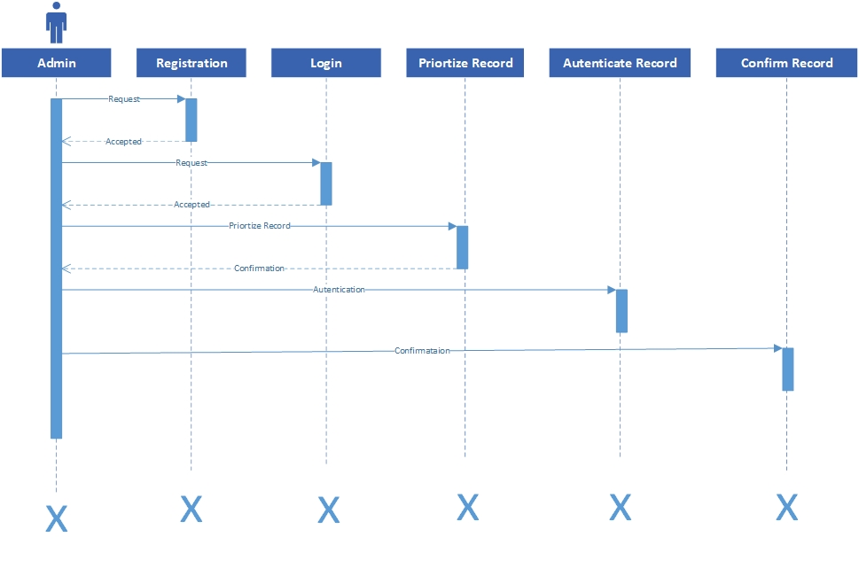

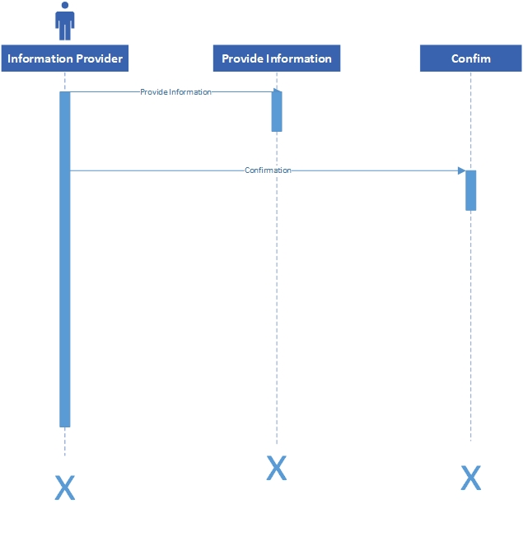

* State Transition Diagram

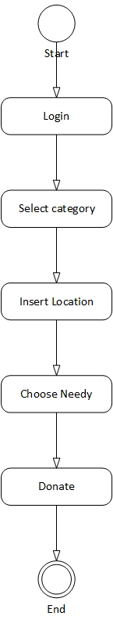

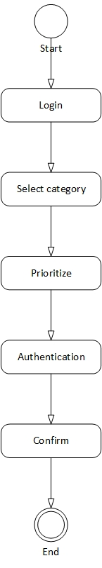

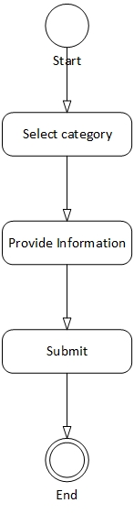

* Data Flow Diagram

Level 0:

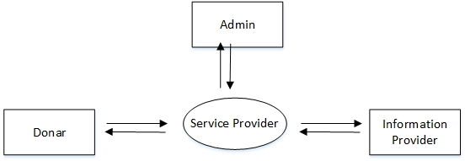

Level 1:

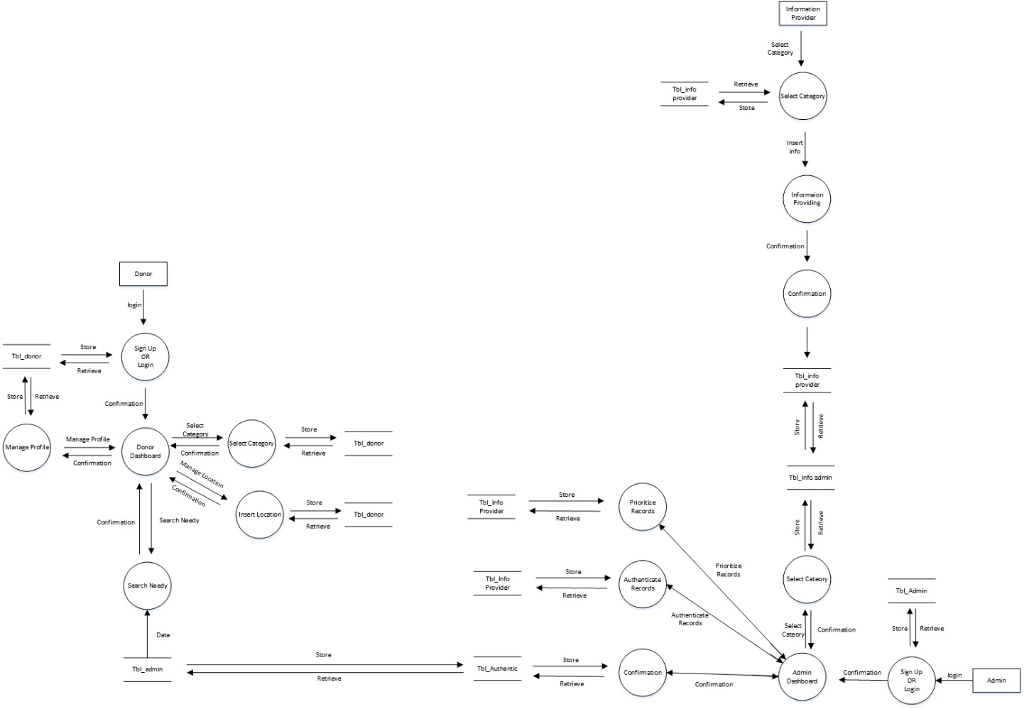

Level 2.0:

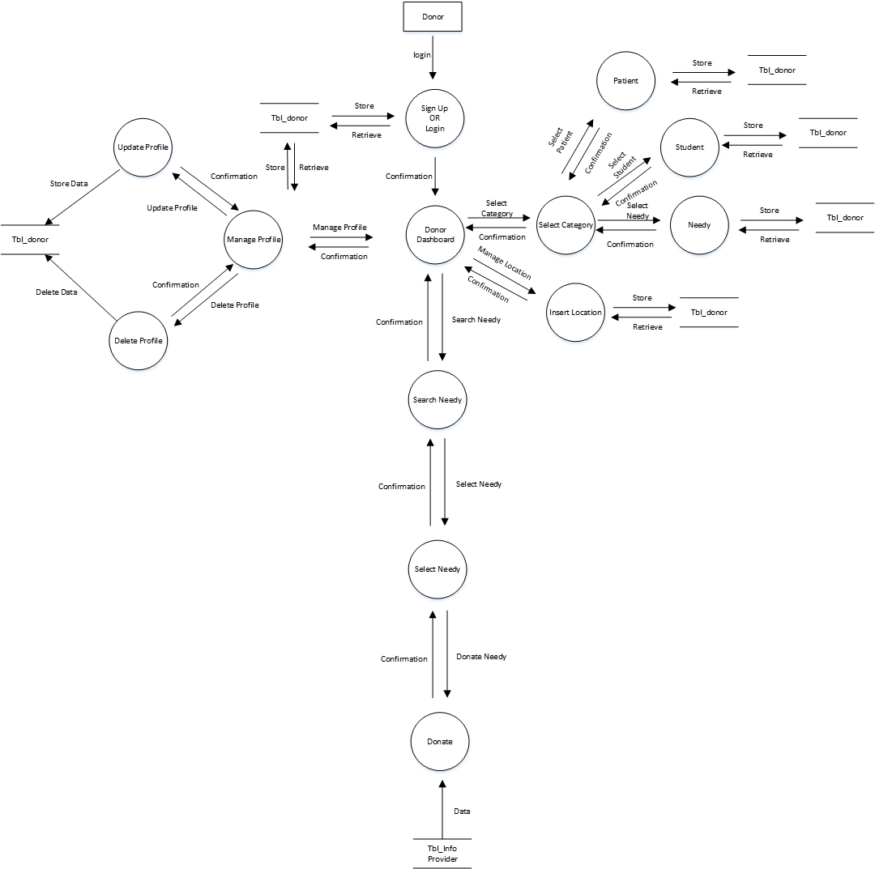

Level 2.1:

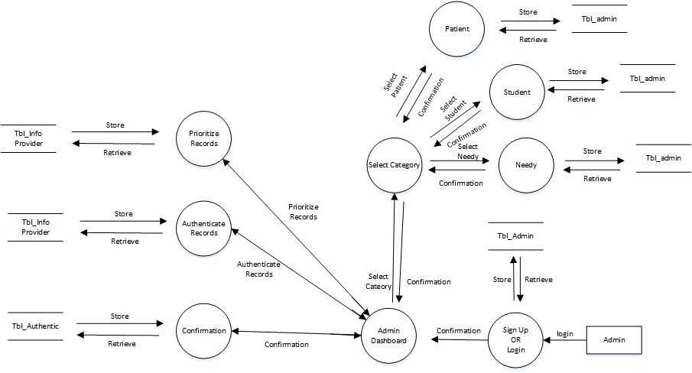

Level 2.2:

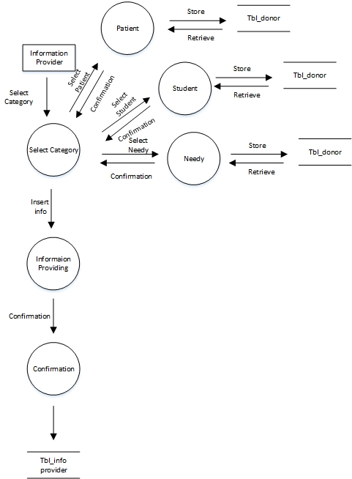

# Data design

Our system will get the information from information providers in the form of documents and an online form. The information will then be verified by Admin and after verification some data in the form of location links. Strings of name & address and contacts will be sent to a database of all verified cases which are shown to the donors.

## Data dictionary

|  |  |  |  |
| --- | --- | --- | --- |
| S.no | Objects | Attributes | Methods |
| 1 | Login | email:string  Password:password | Verify() |
| 2 | Register | Name: string  CNIC: int  DOB: date  Number: int  email: string  Password: password | prioritize()  verify()  savedata() |
| 3 | Donor | Name: string  CNIC: int  DOB: date  Number: int  email: string  Password: password | category ()  location ()  donate () |
| 4 | Dashboard | Name: string  CNIC: int  DOB: date  Number: int  email: string  Password: password  CNIC: document  form: document  location: link | donate_needy()  check_ authenticate()  provide_information() |
| 5 | Information Provider | name: string  number: int  CNIC: document  form: document  location: link | submit_details() |
| 6 | Admin | Name: string  CNIC: int  DOB: date  Number: int  email: string  Password: password | verify_cases()  prioritize_cases() |

# Appendix I

• How to design using UML (OOP): For guidance please follow the instructionsmentioned in the link: http://incrementalmodeling.com/artifacts/

* Data flow diagrams: For guidance please follow the instructions mentioned in the link and book:o http://www. incrementalmodeling.com/artifacts/dataFlowDiagram.htmSoftware Engineering –A Practitioner‟s approach by Roger Pressman

o

* Architecture diagram: For guidance please follow the instructions mentioned in the link and book:

o Ian Sommerville – Software Engineering 9th Edition– Chapter 6